EXPERIMENT – 39
AIM :
To segment customers based on spending and purchase behavior using the K-Means clustering algorithm and visualize the customer groups.

ALGORITHM :
- Load the transaction dataset (or create sample data if missing).
- Select features: total amount spent & number of items purchased.
- Scale the data for better clustering performance.
- Apply K-Means clustering with a chosen number of clusters (e.g., k=3).
- Assign each customer to a cluster.
- Visualize the clusters using scatter plots.
- Interpret customer segments.

CODE :
import pandas as pd
from sklearn.preprocessing import StandardScaler
from sklearn.cluster import KMeans
import matplotlib.pyplot as plt
import os

file_name = "customer_transactions.csv"

# ✅ Load dataset or create sample data
if os.path.exists(file_name):
data = pd.read_csv(file_name)
print("✅ File loaded successfully!\n")
else:
print("⚠️ File not found! Using sample data...\n")
data = pd.DataFrame({
'Customer_ID': [101, 102, 103, 104, 105, 106],
'Total_Spent': [500, 1500, 300, 2000, 700, 1200],
'Items_Purchased': [5, 15, 3, 20, 7, 12]
})

# Select features
X = data[['Total_Spent', 'Items_Purchased']]

# Scale the data
scaler = StandardScaler()
X_scaled = scaler.fit_transform(X)

# Apply K-Means
kmeans = KMeans(n_clusters=3, random_state=0)
data['Cluster'] = kmeans.fit_predict(X_scaled)

# Display results
print("=== Customer Segmentation Results ===\n")
print(data)

# Plot clusters
plt.scatter(data['Total_Spent'], data['Items_Purchased'], c=data['Cluster'], s=100)
plt.title("Customer Segmentation using K-Means")
plt.xlabel("Total Amount Spent")
plt.ylabel("Items Purchased")
plt.grid(True)
plt.show()

INPUT :
A CSV file named customer_transactions.csv with columns:
Customer_ID, Total_Spent, Items_Purchased
If missing, sample data is used automatically.

OUTPUT :
⚠️ File not found! Using sample data...

=== Customer Segmentation Results ===

Customer_ID Total_Spent Items_Purchased Cluster
0 101 500 5 2
1 102 1500 15 0
2 103 300 3 2
3 104 2000 20 0
4 105 700 7 1
5 106 1200 12 1
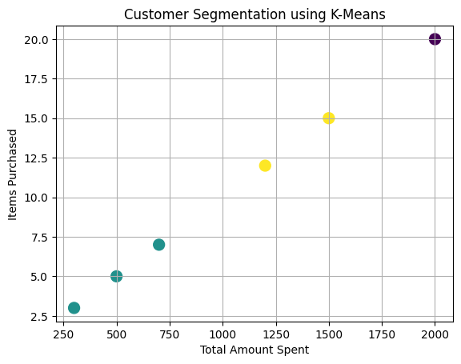
RESULT :
Customers are successfully grouped into distinct segments based on spending and purchase behavior, helping the company target marketing strategies effectively.

